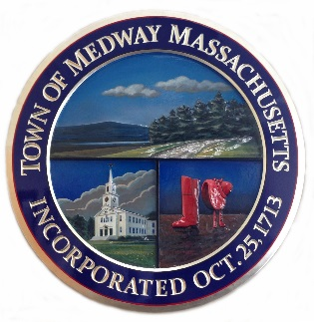

Town of Medway
155 Village Street
Medway, MA 02053

Sunshine New Hire – Check list

Work Permit if under age 18 – available at employee’s school
Demographic Form
Federal W-4
State M-4
Town’s Direct Deposit Form – include a voided check or a bank-issued direct deposit form (required)
Social Security Acknowledgment Form
OBRA Enrollment Form completed in entirety. Mandatory for ALL.
CORI Form if over age 18 with a copy of Driver’s License or ID
I-9- must be accompanied by 1. valid passport OR 2. ID and Birth Certificate
Seasonal Policy Acknowledgement

Forms: https://medwayma.gov/departments/human-resources/employee-forms (part-time)

Forms are to be returned to Human Resources at Town Hall by appointment only. Please contact HR Manager, Cheryl Houle for an appointment after your checklist is complete.

choule@townofmedway.org
508-321-4943
Office hours: M 8-5, T 8-4, W 8-4, Th 8-4, F 8-12

